**Evidence Gathering Document for SQA Level 8 Professional Developer Award.**

This document is designed for you to present your screenshots and diagrams relevant to the PDA and to also give a short description of what you are showing to clarify understanding for the assessor.

Each point that required details the Assessment Criteria (What you have to show) along with a brief description of the kind of things you should be showing.

Please fill in each point with screenshot or diagram and description of what you are showing.

**Week 2**

| Unit | Ref | Evidence |  |
| --- | --- | --- | --- |
| I&T | I.T.5 | Demonstrate the use of an array in a program. Take screenshots of:  *An array in a program  *A function that uses the array  *The result of the function running | |
|  |  | **Description:** | |

**Paste Screenshot here**



**Description here**

The array ‘arr’ contains the numbers 1 through 5. The function totalNumbers takes an array of numbers as a parameter, adds each number together and returns the total.

| Unit | Ref | Evidence |  |
| --- | --- | --- | --- |
| I&T | I.T.6 | Demonstrate the use of a hash in a program. Take screenshots of:  *A hash in a program  *A function that uses the hash  *The result of the function running | |
|  |  | **Description:** | |

**Paste Screenshot here**

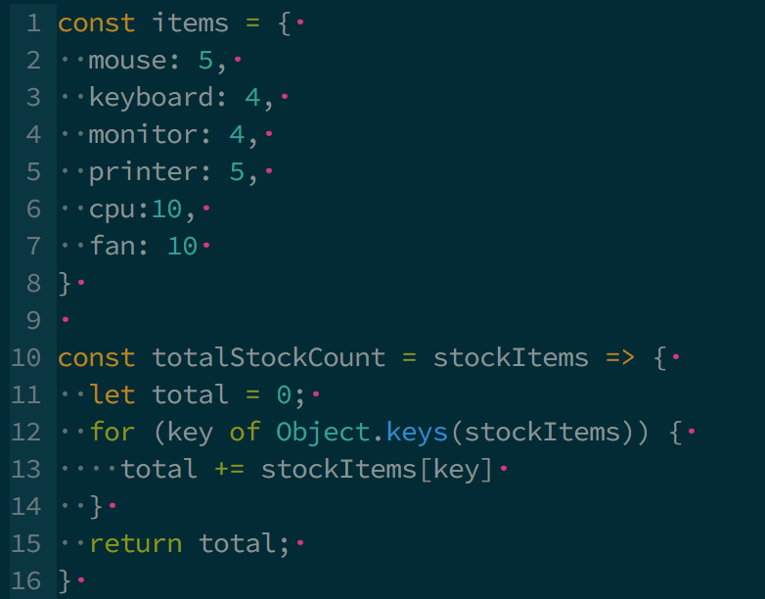

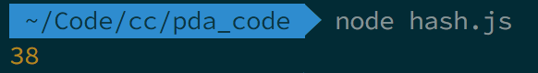

**Description here**

The hash in the program contains the stock count for each item in the shop. The function totalStockCount loops through each key in the hash and returns the total stock count. The output above shows the result of the function when logged out.

**Week 3**

| Unit | Ref | Evidence |  |
| --- | --- | --- | --- |
| I&T | I.T.3 | Demonstrate searching data in a program. Take screenshots of:  *Function that searches data  *The result of the function running | |
|  |  | **Description:** | |

**Paste Screenshot here**

**Description here**

The ‘Customer’ class ‘all’ method (function) searches a database using the query string saved in the ‘sql’ variable. Running the method in pry returns an array of ‘Customer’ objects created from the search results.

| Unit | Ref | Evidence |  |
| --- | --- | --- | --- |
| I&T | I.T.4 | Demonstrate sorting data in a program. Take screenshots of:  *Function that sorts data  *The result of the function running | |
|  |  | **Description:** | |

**Paste Screenshot here**



**Description here**

The ‘Album’ class ‘all’ method (function) searches a database using the query string saved in the ‘sql’ variable. The sql query includes an ORDER BY clause which sorts the returned data depending on the method arguments given. Running the method in pry returns an array of ‘Album’ objects created from the search results and in this case ordered by ‘title’ in ascending order.

**Week 5 and 6**

| Unit | Ref | Evidence |  |
| --- | --- | --- | --- |
| A&D | A.D.1 | A Use Case Diagram | |
|  |  | **Description:** | |

**Paste Screenshot here**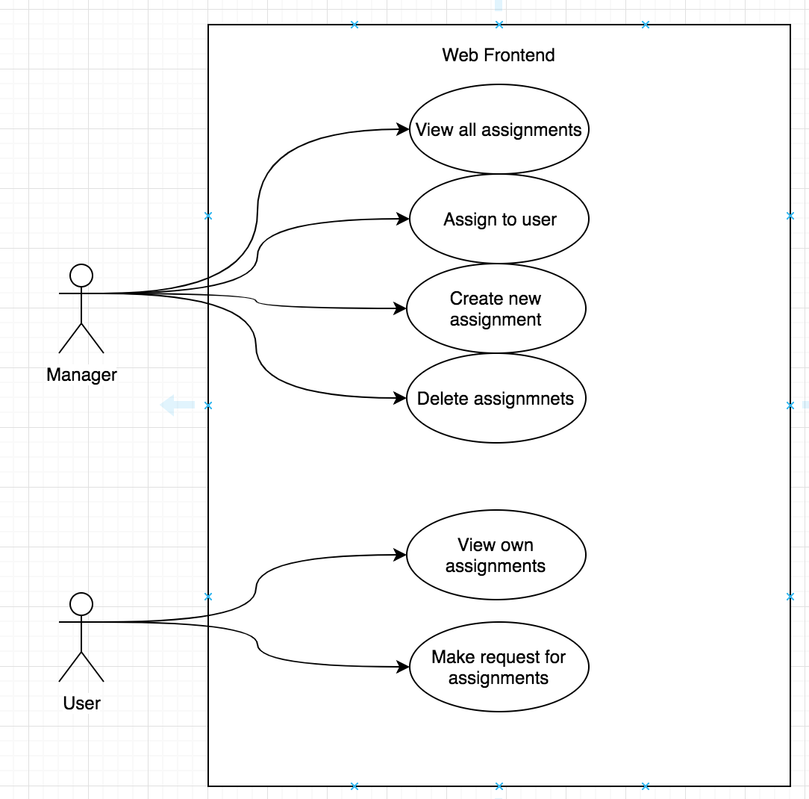

**Description here**

The above use case diagram shows shows the usage requirements for both managers and users for an assignment system

| Unit | Ref | Evidence |  |
| --- | --- | --- | --- |
| A&D | A.D.2 | A Class Diagram | |
|  |  | **Description:** | |

**Paste Screenshot here**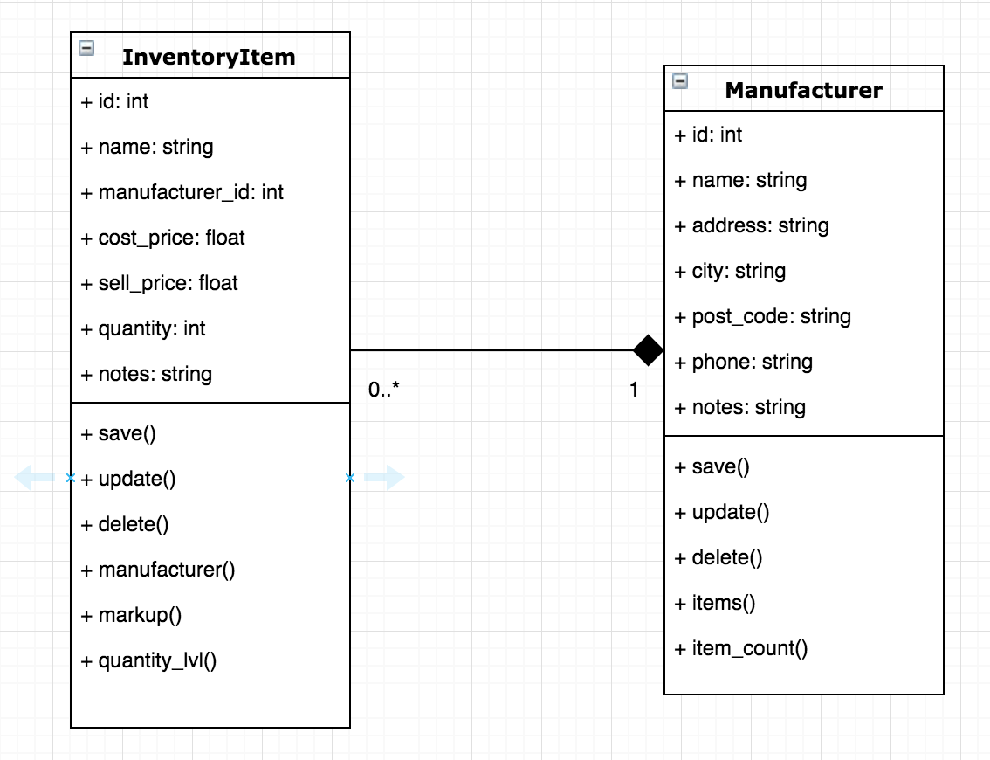

**Description here**

The above class diagram describes the classes and relationship for a shop inventory system. There is a one to many relationship between a manufacturer and inventory items.

| Unit | Ref | Evidence |  |
| --- | --- | --- | --- |
| A&D | A.D.3 | An Object Diagram | |
|  |  | **Description:** | |

**Paste Screenshot here**

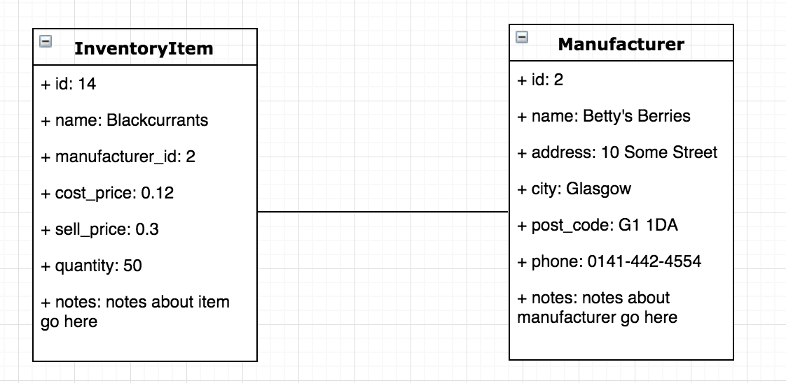

**Description here**

This is an object diagram showing the attribute values for instances of the manufacturer and InventoryItem classes described above.

| Unit | Ref | Evidence |  |
| --- | --- | --- | --- |
| A&D | A.D.4 | An Activity Diagram | |
|  |  | **Description:** | |

**Paste Screenshot here**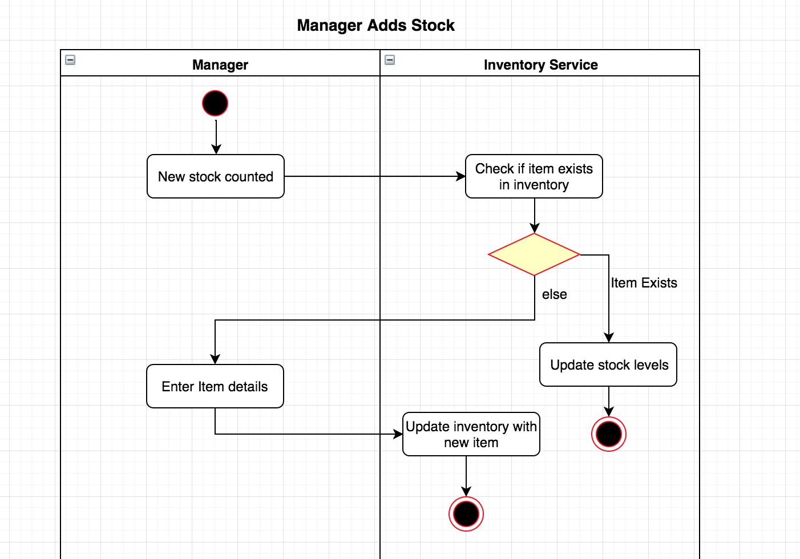

**Description here**

The above activity diagram shows the activities involved in a shop manager using the inventory system to update the stock levels in the shop.

| Unit | Ref | Evidence |  |
| --- | --- | --- | --- |
| A&D | A.D.6 | Produce an Implementations Constraints plan detailing the following factors:  *Hardware and software platforms  *Performance requirements  *Persistent storage and transactions  *Usability  *Budgets  *Time | |
|  |  | **Description:** | |

**Paste Screenshot here**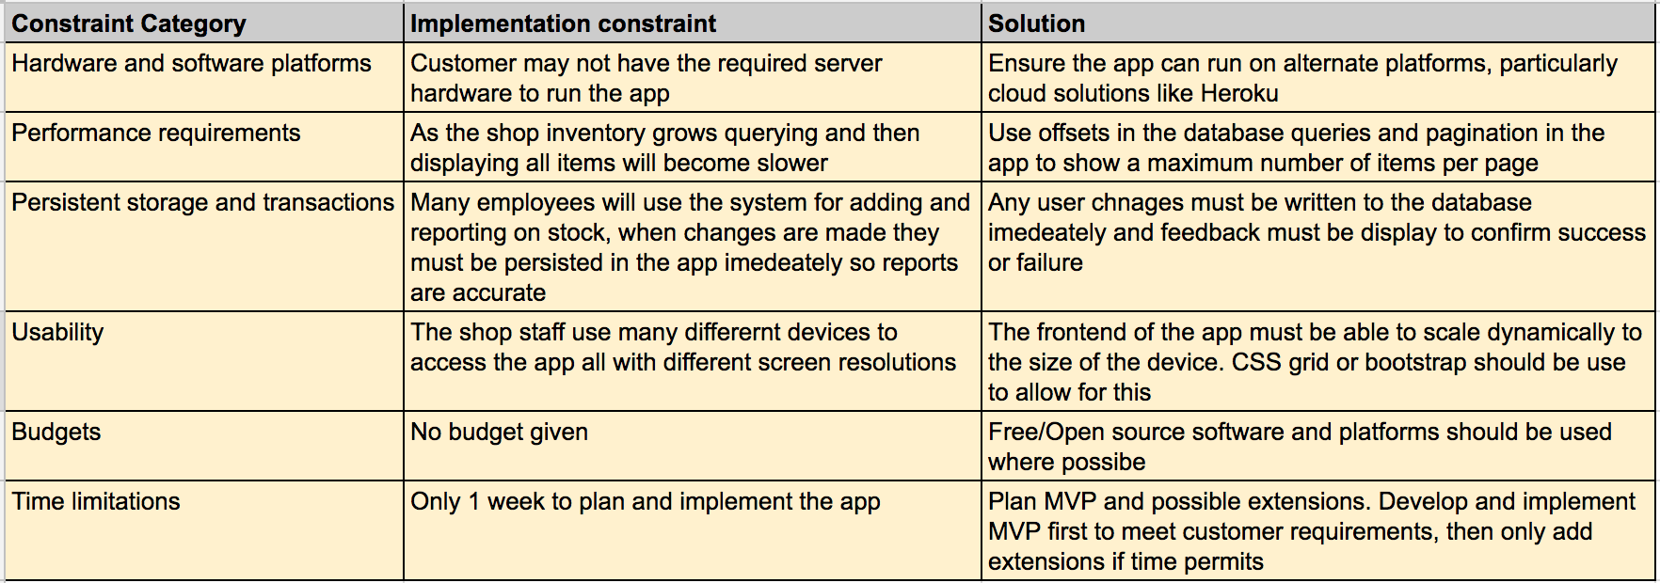

**Description here**

Implementations Constraints for a shop inventory management application.

| Unit | Ref | Evidence |  |
| --- | --- | --- | --- |
| P | P.5 | User Site Map | |
|  |  | **Description:** | |

**Paste Screenshot here**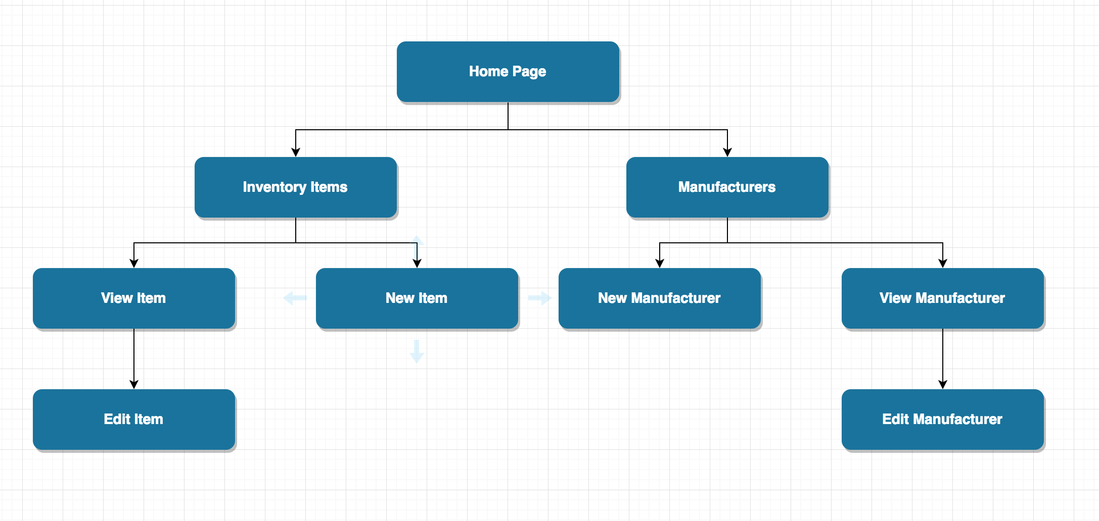

**Description here**

Site map for a shop inventory system

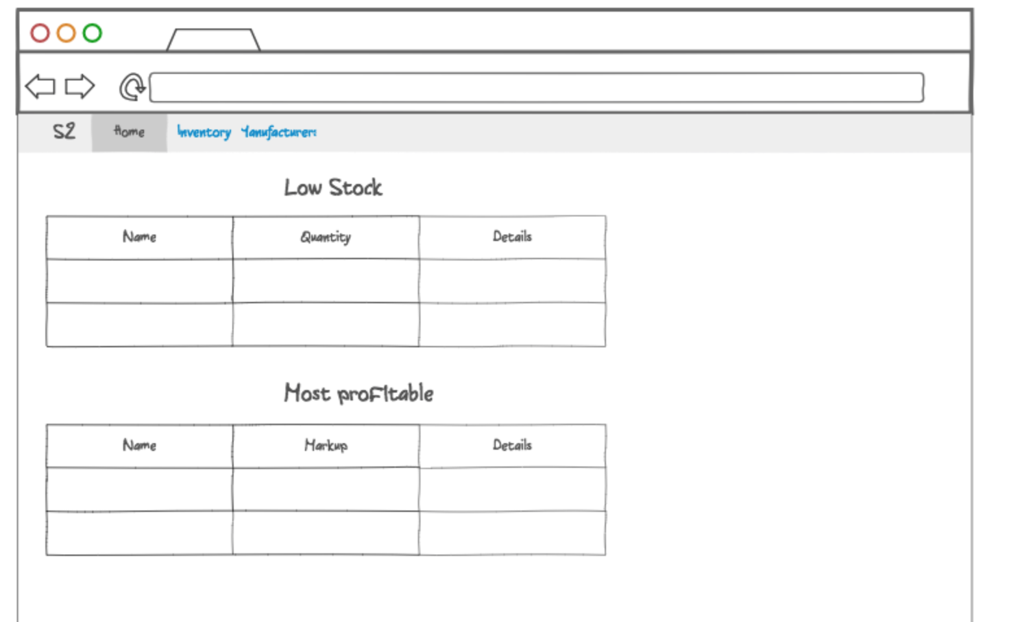

| Unit | Ref | Evidence |  |
| --- | --- | --- | --- |
| P | P.6 | 2 Wireframe Diagrams | |
|  |  | **Description:** | |

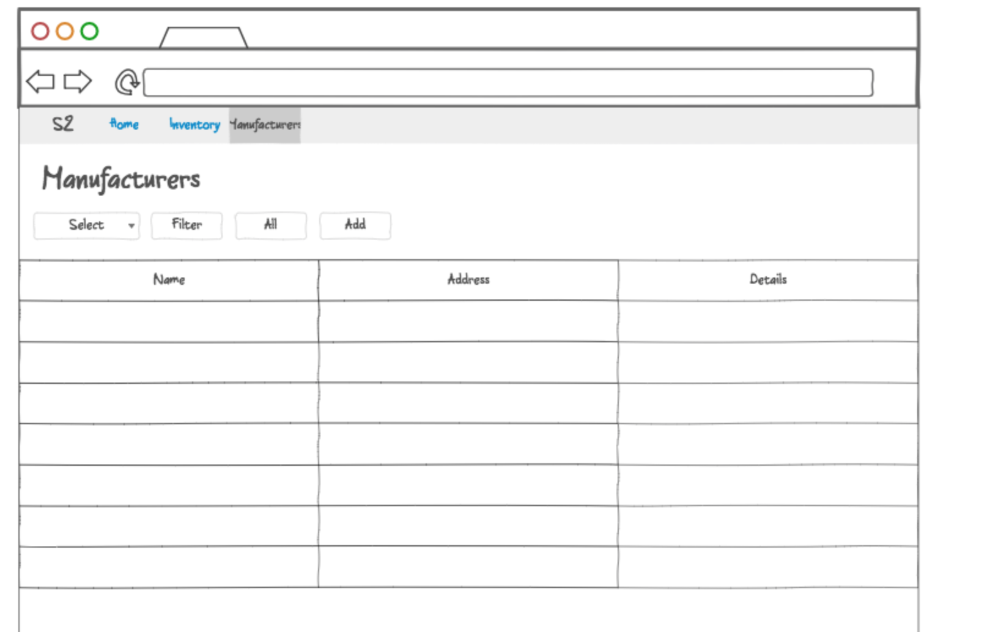

**Description here**

Wire frame diagrams for a shop inventory application. The first shows the homepage with summary and the second the manufacturers page showing details and options to filter the view and add new manufacturers.

| Unit | Ref | Evidence |  |
| --- | --- | --- | --- |
| P | P.10 | Example of Pseudocode used for a method | |
|  |  | **Description:** | |

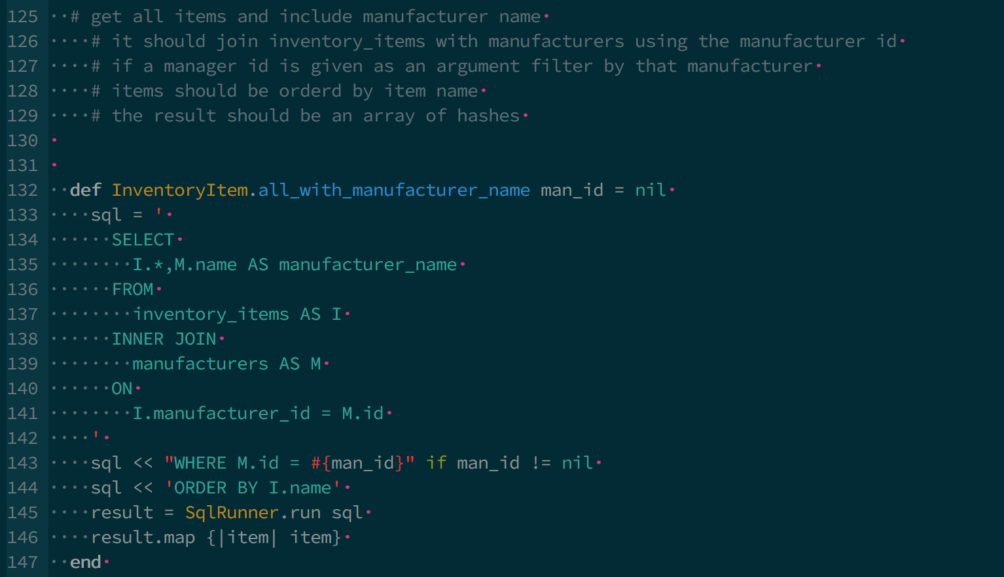

**Paste Screenshot here**

**Description here**

The above pseudocode describes the functionality required from the all_with_manufacturer_name class method

| Unit | Ref | Evidence |  |
| --- | --- | --- | --- |
| P | P.13 | Show user input being processed according to design requirements. Take a screenshot of:  * The user inputting something into your program  * The user input being saved or used in some way | |
|  |  | **Description:** | |

**Paste Screenshot here**

**Description here**

The user inputs a manufacturer and clicks on the filter button. The user input is then used to return a filtered list by manufacturer.

| Unit | Ref | Evidence |  |
| --- | --- | --- | --- |
| P | P.14 | Show an interaction with data persistence. Take a screenshot of:  * Data being inputted into your program  * Confirmation of the data being saved | |
|  |  | **Description:** | |

**Paste Screenshot here**



**Description here**

The user enters information about the new manufacturer and clicks the add button. The data is persisted in a Postgres database and the saved data is then returned on a new page confirming the data being saved. Confirmation is below as per the output evidence.

| Unit | Ref | Evidence |  |
| --- | --- | --- | --- |
| P | P.15 | Show the correct output of results and feedback to user. Take a screenshot of:  * The user requesting information or an action to be performed  * The user request being processed correctly and demonstrated in the program | |
|  |  | **Description:** | |

**Paste Screenshot here**



**Description here**

| Unit | Ref | Evidence |  |
| --- | --- | --- | --- |
| P | P.11 | Take a screenshot of one of your projects where you have worked alone and attach the Github link. | |
|  |  | **Description:** | |

**Paste Screenshot here**

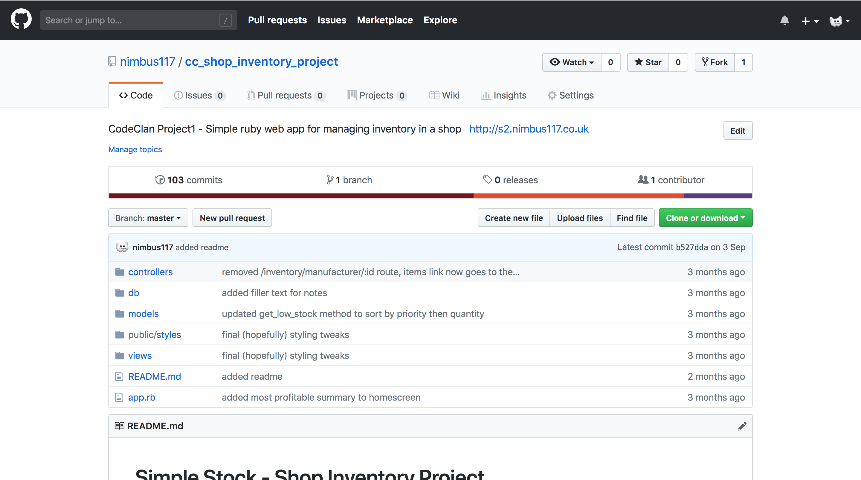

**Description here**

Above is a screenshot of the GitHub repo I used for my solo Ruby project.

| Unit | Ref | Evidence |  |
| --- | --- | --- | --- |
| P | P.12 | Take screenshots or photos of your planning and the different stages of development to show changes. | |
|  |  | **Description:** | |

**Paste Screenshot here**





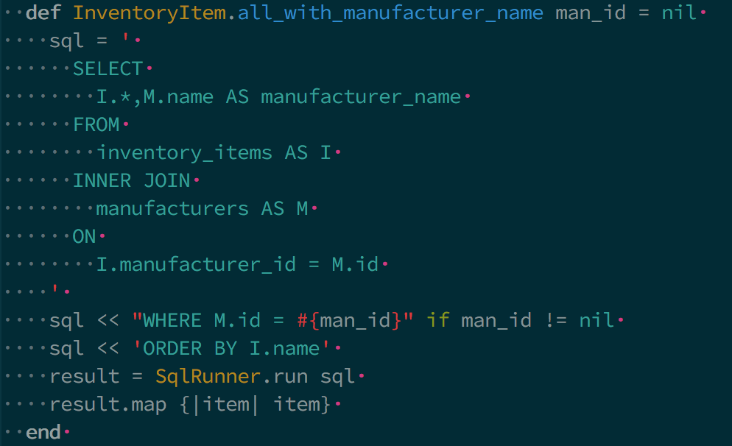

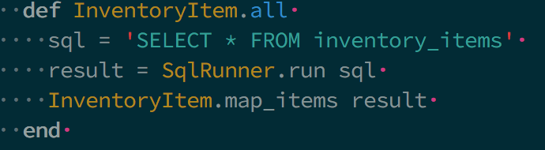

**Description here**

The above screenshots show the initial rough plan and then notes added during the project about required changes. Based on these I did a more detailed class diagram and planned the site structure. The code screenshots show the original “all” method and then the updated one after, which includes manufacturer name in the returned object.

**Week 7**

| Unit | Ref | Evidence |  |
| --- | --- | --- | --- |
| P | P.16 | Show an API being used within your program. Take a screenshot of:  * The code that uses or implements the API  * The API being used by the program whilst running | |
|  |  | **Description:** | |

**Paste Screenshot here**

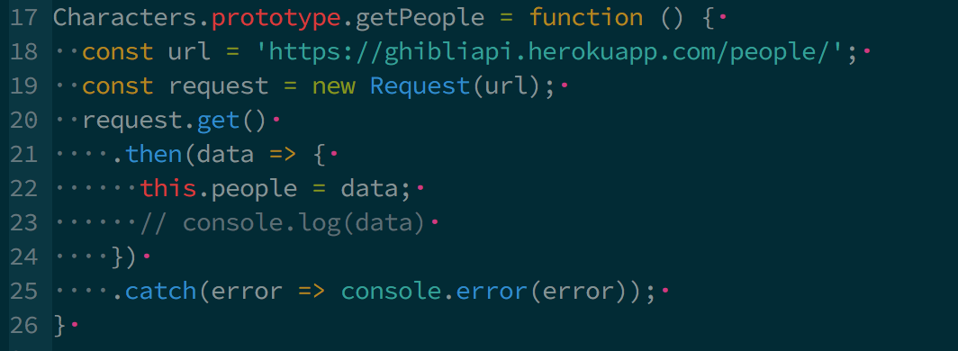

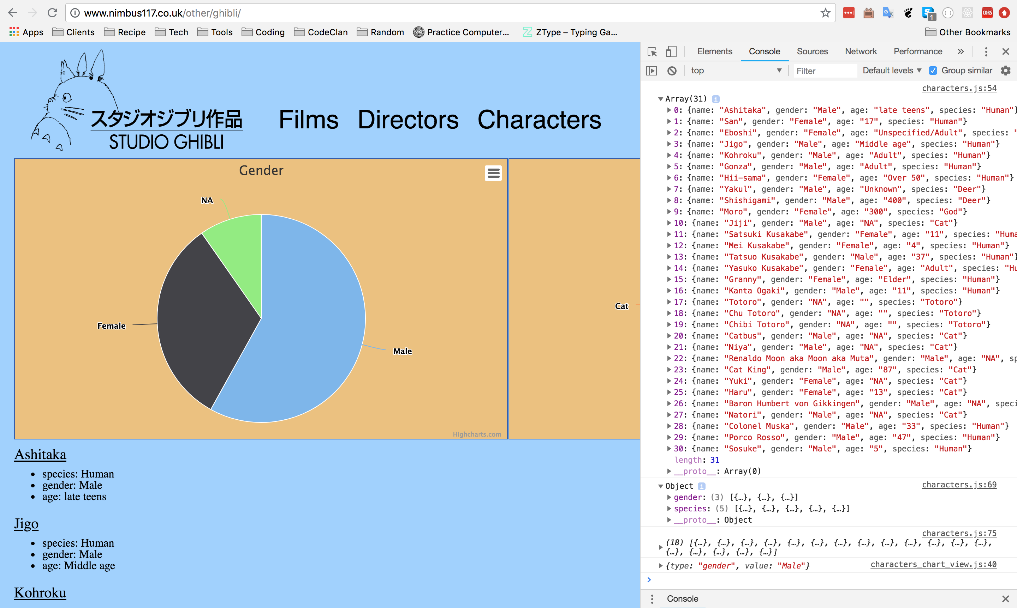

**Description here**

The above screenshot show thee code used to make a request against the studio Ghibli API and the page rendered using the data returned from the API.

| Unit | Ref | Evidence |  |
| --- | --- | --- | --- |
| P | P.18 | Demonstrate testing in your program. Take screenshots of:  * Example of test code  * The test code failing to pass  * Example of the test code once errors have been corrected  * The test code passing | |
|  |  | **Description:** | |

**Paste Screenshot here**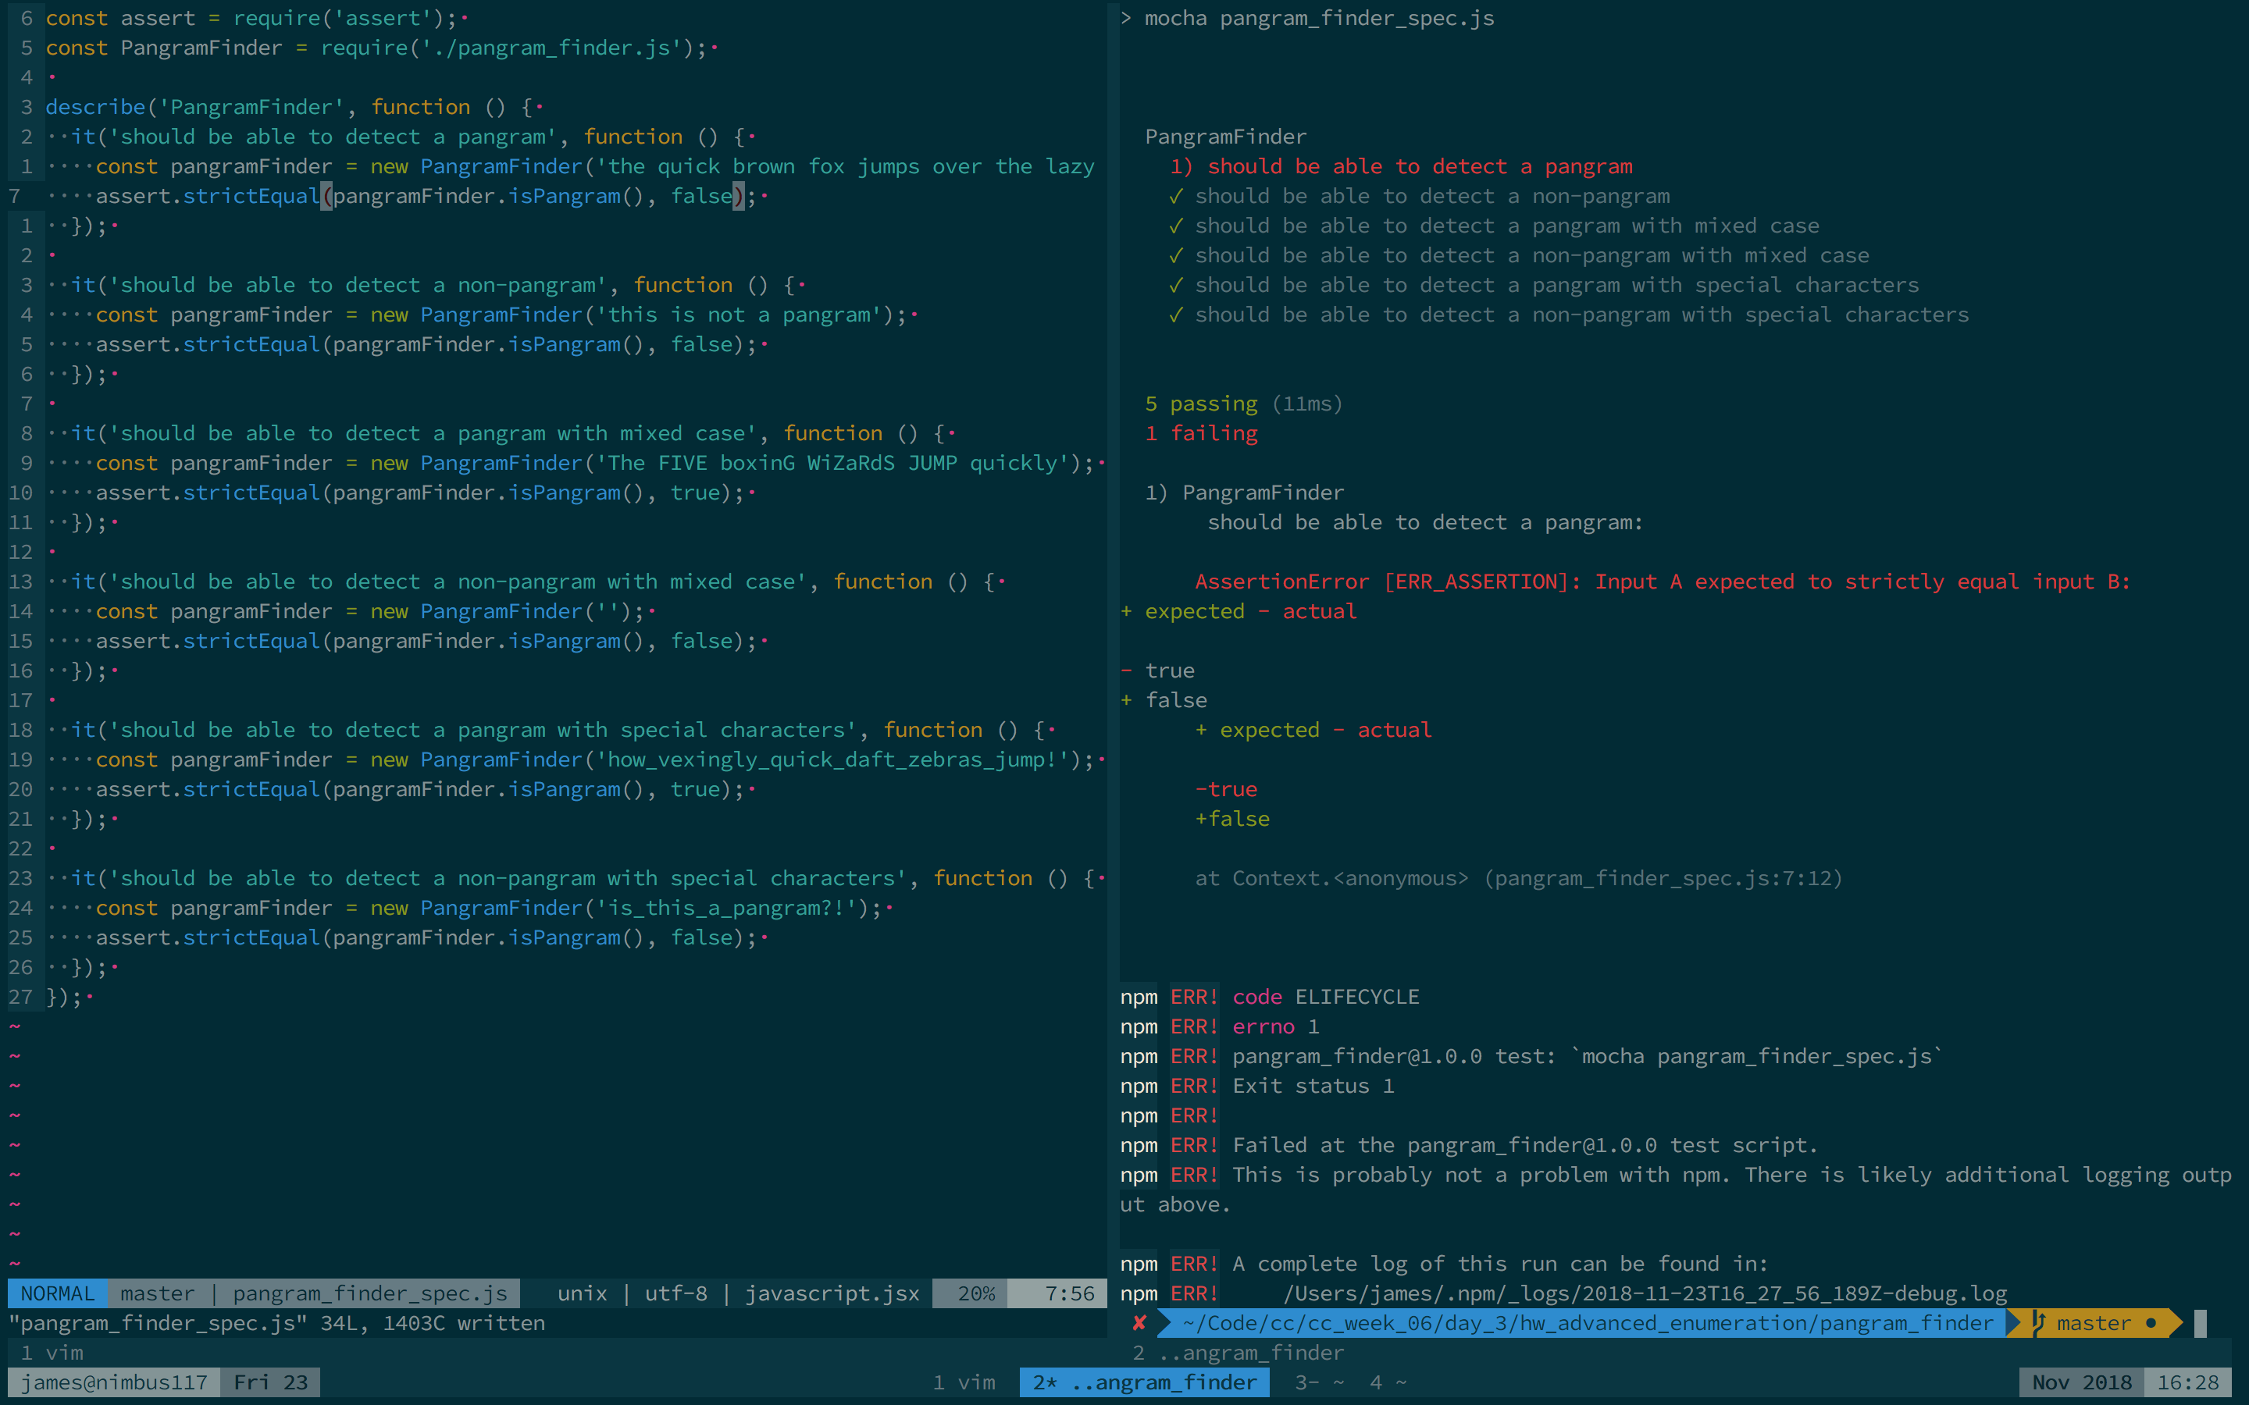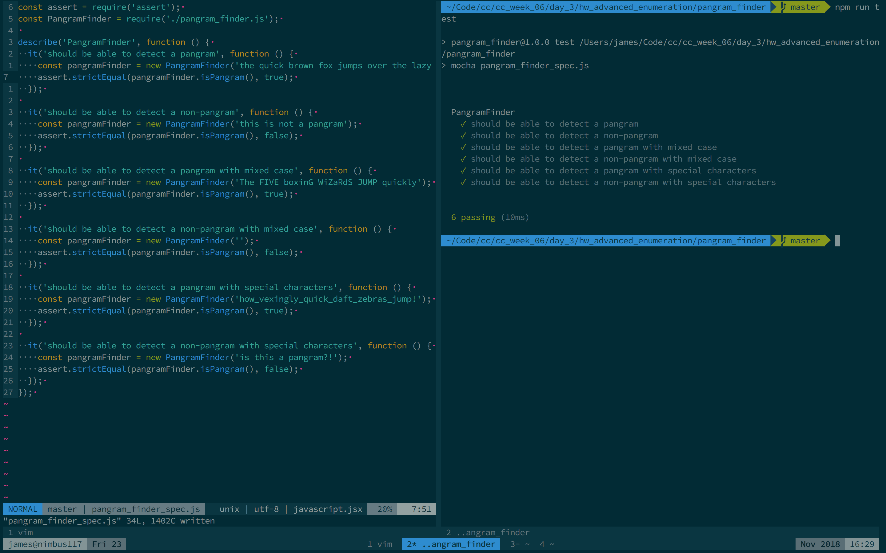

**Description here**

The above screenshots show test code with an error in it and the tests failing, as the wrong output was being tested for, followed by the fixed test code and the passing tests.

**Week 9**

| Unit | Ref | Evidence |  |
| --- | --- | --- | --- |
| P | P.1 | Take a screenshot of the contributor’s page on Github from your group project to show the team you worked with. | |
|  |  | **Description:** | |

**Paste Screenshot here**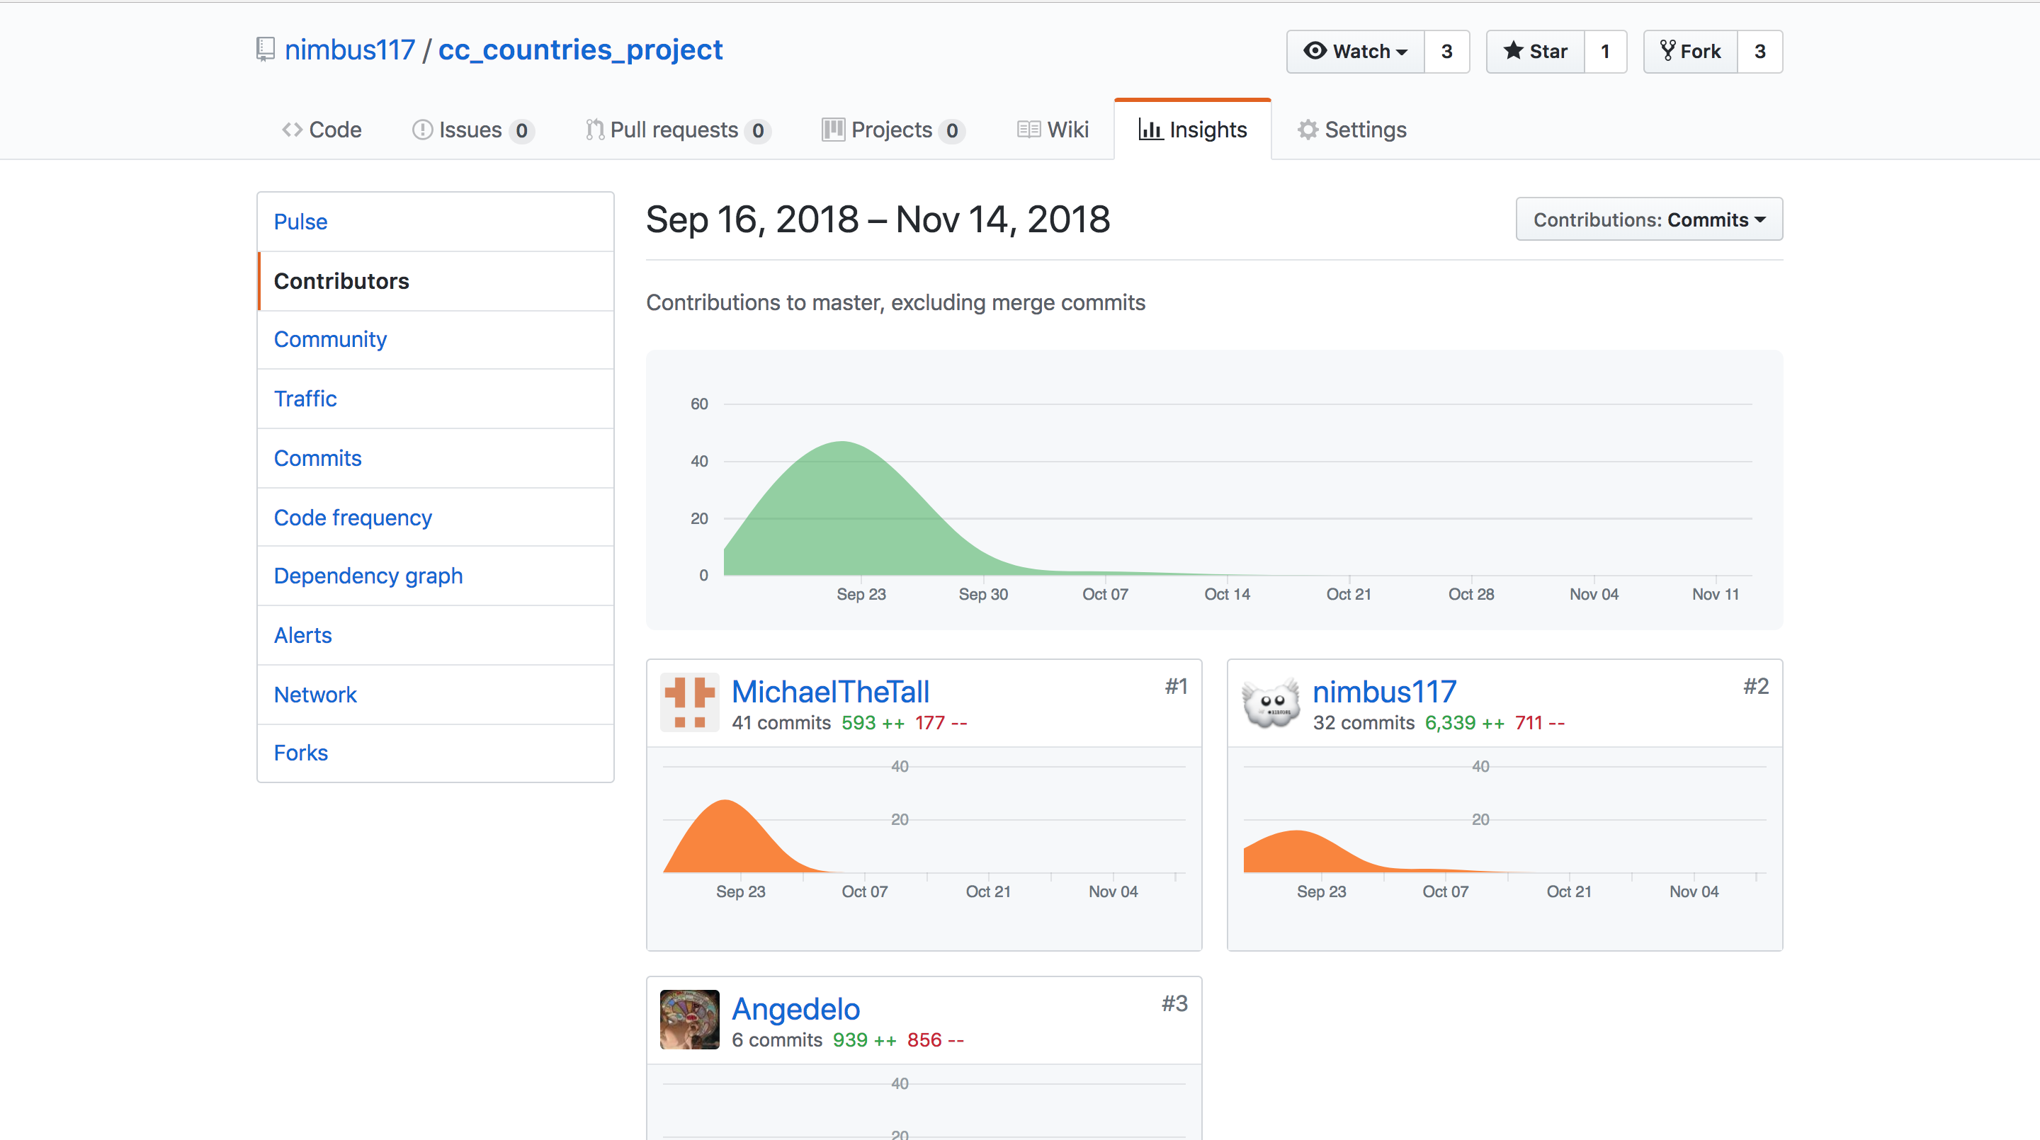

**Description here**

The above screenshot shows thee contributors page on GitHub for the Countries JavaScript group project - <https://github.com/nimbus117/cc_countries_project>

| Unit | Ref | Evidence |  |
| --- | --- | --- | --- |
| P | P.2 | Take a screenshot of the project brief from your group project. | |
|  |  | **Description:** | |

**Paste Screenshot here**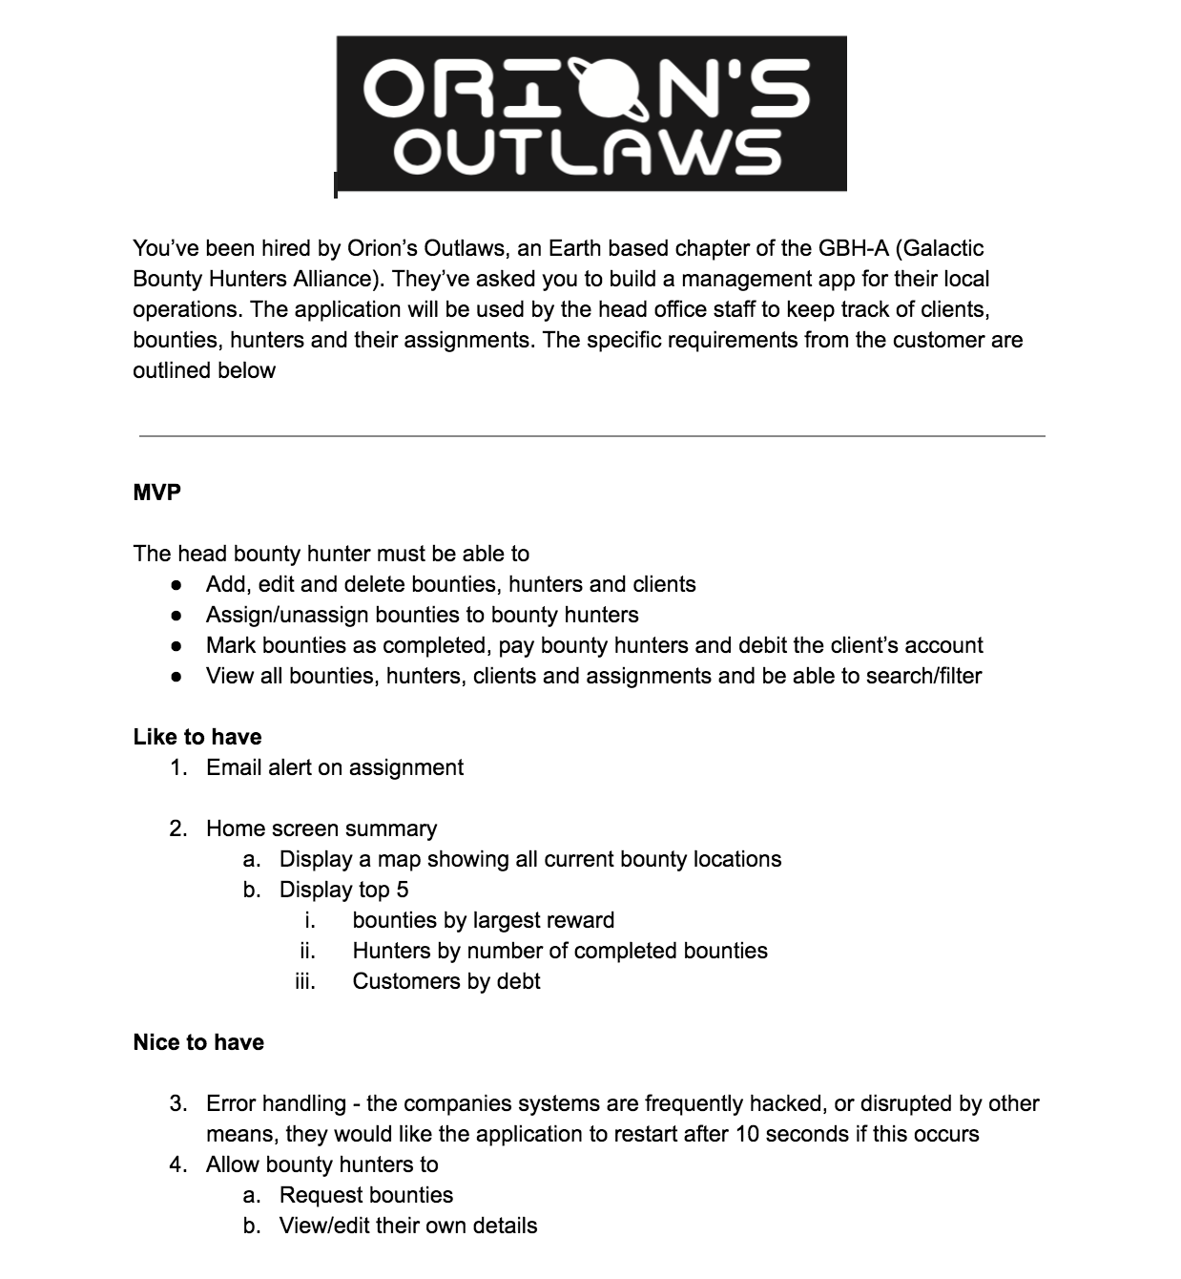

**Description here**

The above shows the project brief we wrote for our group project

| Unit | Ref | Evidence |  |
| --- | --- | --- | --- |
| P | P.3 | Provide a screenshot of the planning you completed during your group project, e.g. Trello MOSCOW board. | |
|  |  | **Description:** | |

**Paste Screenshot here**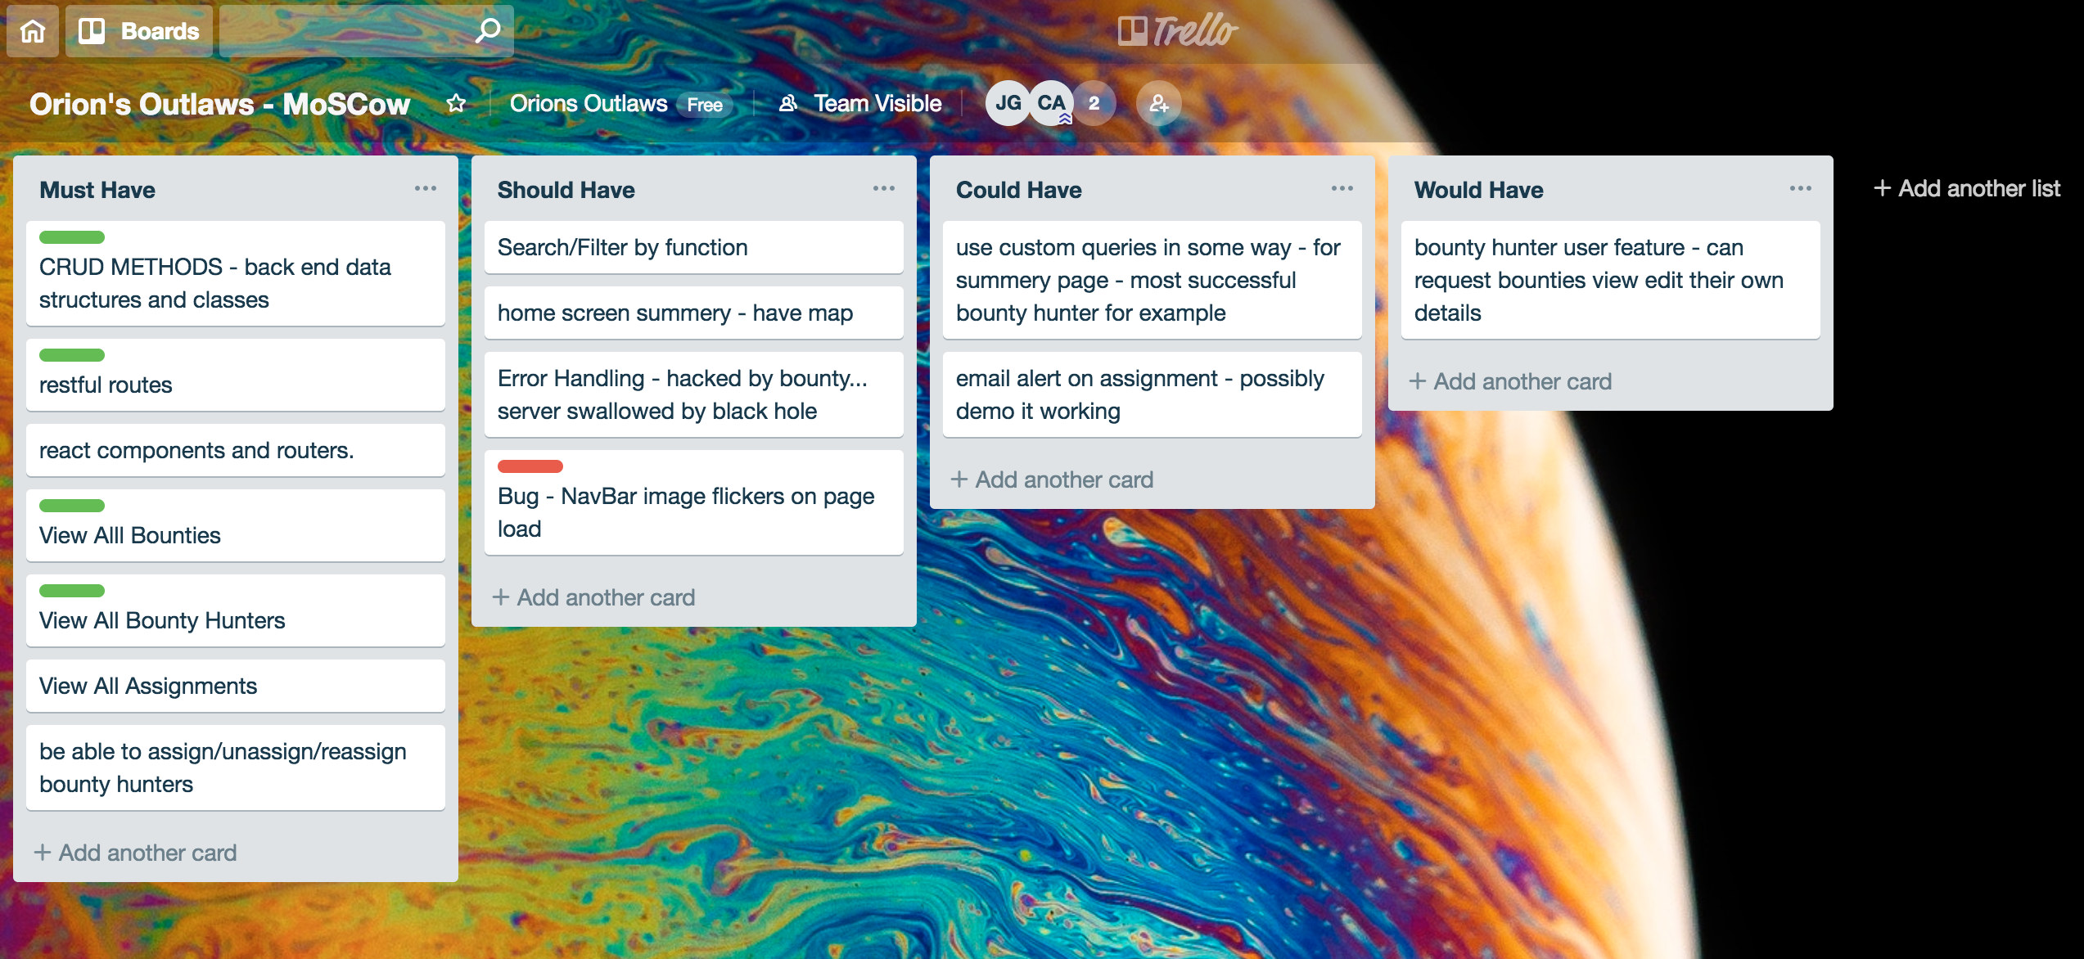

**Description here**

The above screenshot shows the trello/moscow board we used for planning during the group project.

| Unit | Ref | Evidence |  |
| --- | --- | --- | --- |
| P | P.4 | Write an acceptance criteria and test plan. | |
|  |  |  | |

**Paste Screenshot here**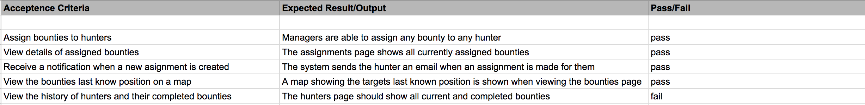

**Description here**

The above acceptance criteria shows the main criteria for the app, the expected output from the app and whether the criteria was met.

| Unit | Ref | Evidence |  |
| --- | --- | --- | --- |
| P | P.7 | Produce two system interaction diagrams (sequence and/or collaboration diagrams). | |
|  |  | **Description:** | |

**Paste Screenshot here**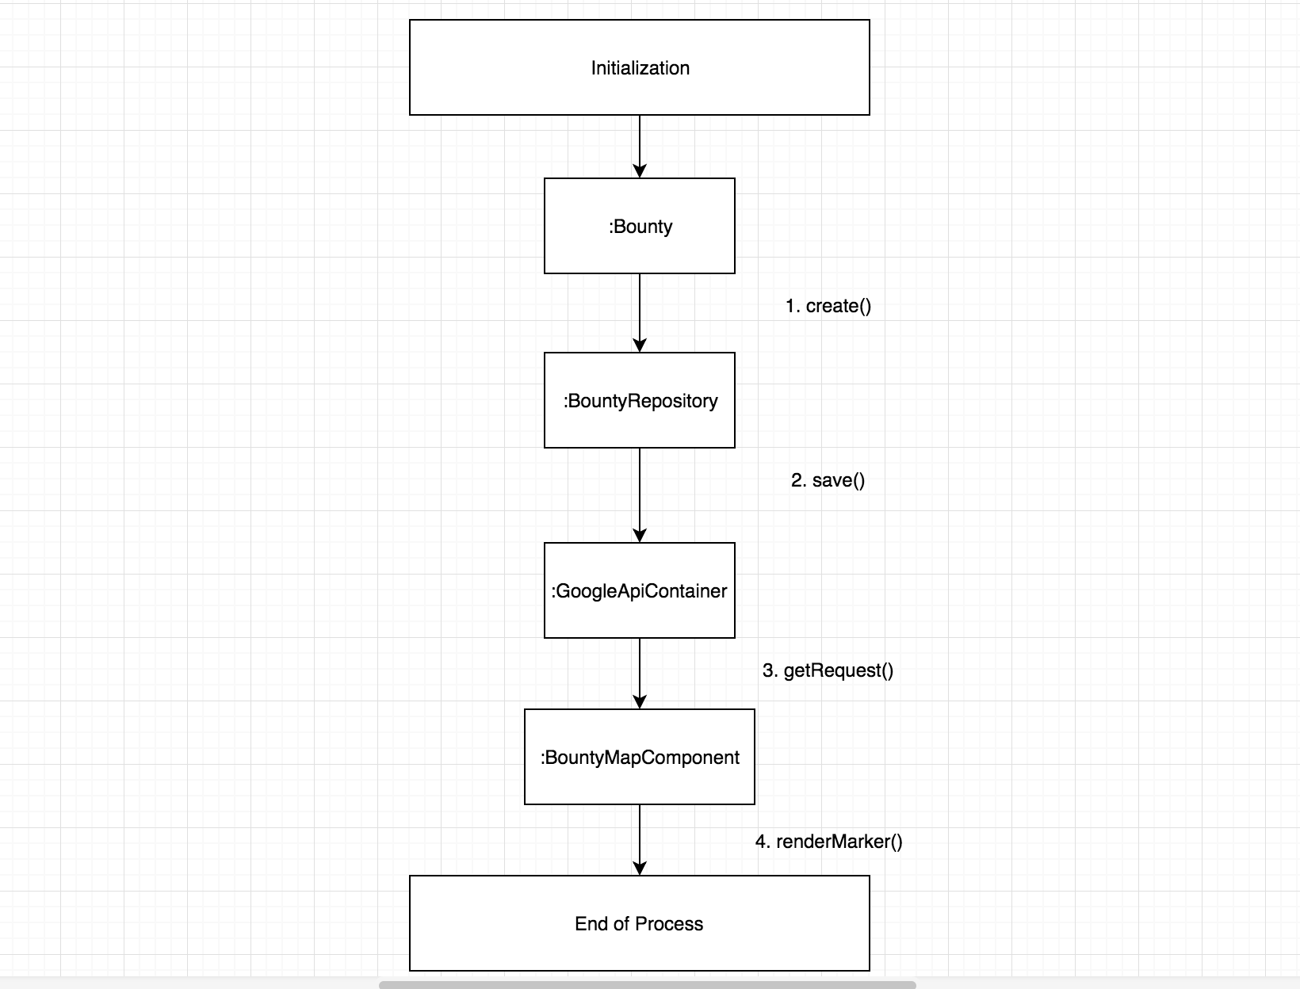

Above is a Collaboration diagram for a bounty assignment system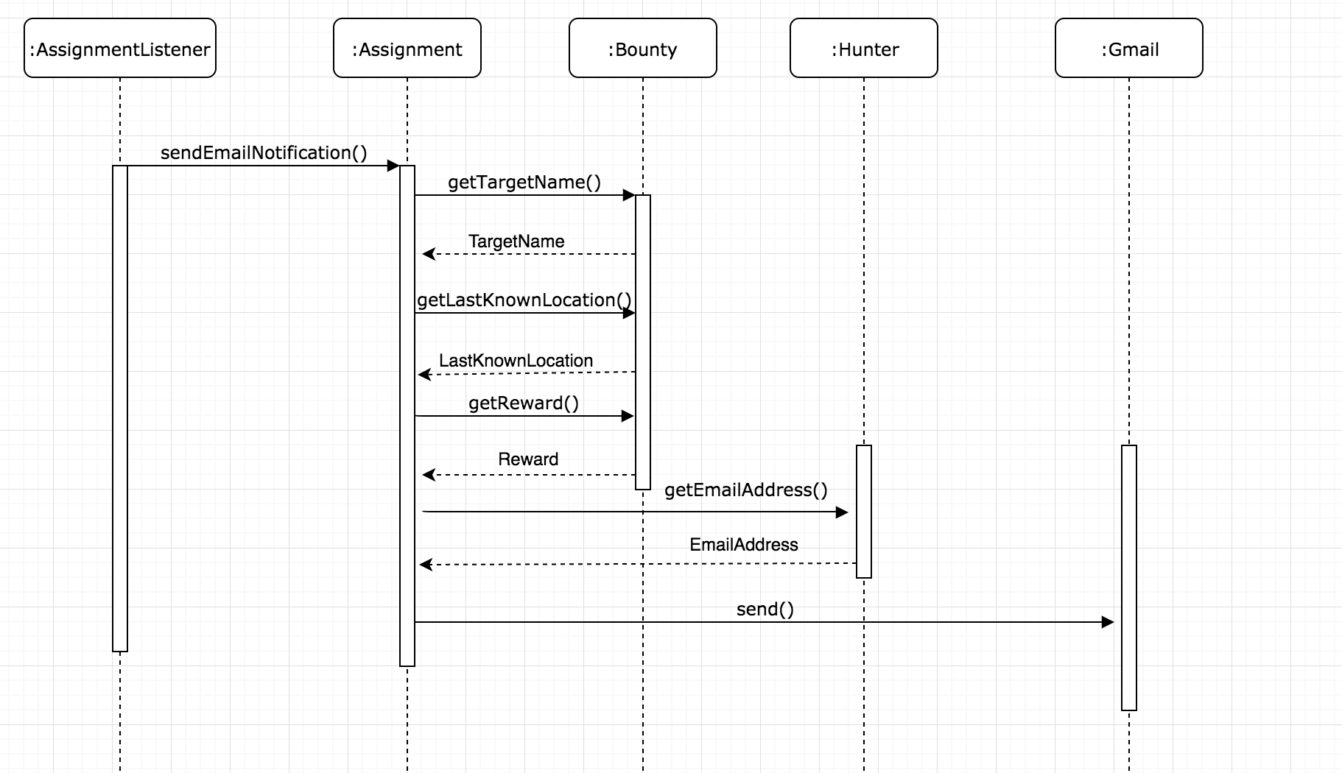

The above sequence diagram shows the messages (and their order) sent between classes in order to send an assignment email

| Unit | Ref | Evidence |  |
| --- | --- | --- | --- |
| P | P.8 | Produce two object diagrams. | |
|  |  | **Description:** | |

**Paste Screenshot here**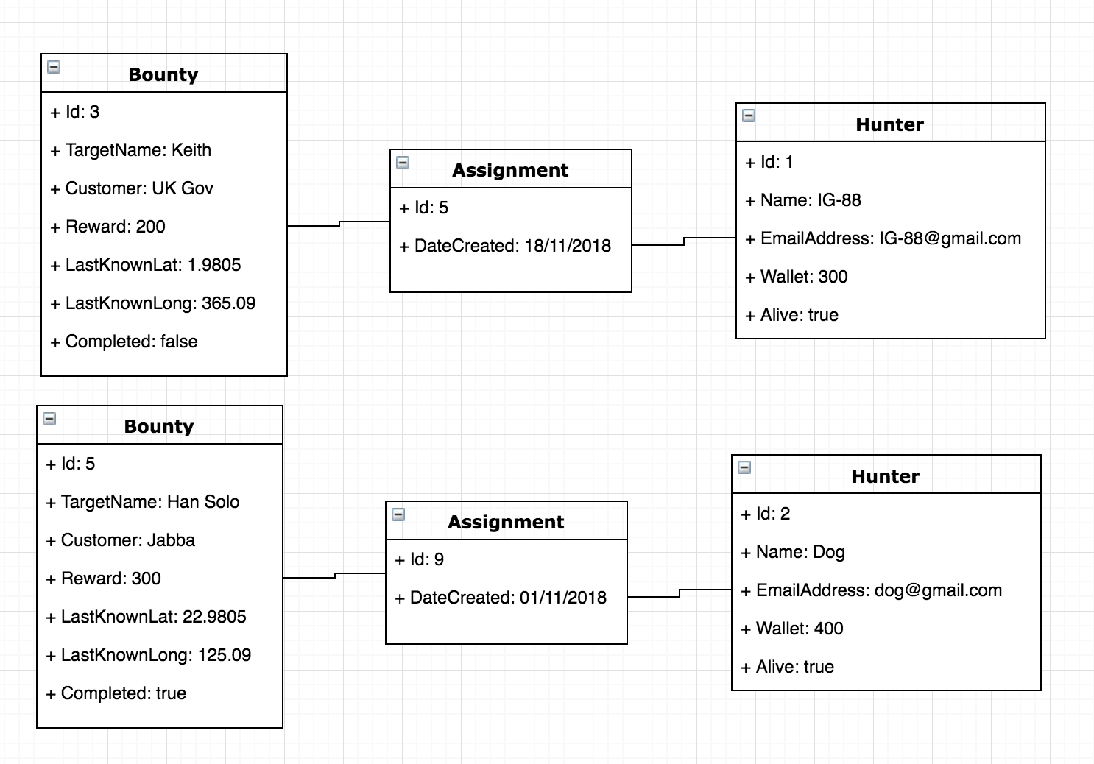

| Unit | Ref | Evidence |  |
| --- | --- | --- | --- |
| P | P.17 | Produce a bug tracking report | |
|  |  | **Description:** | |

**Paste Screenshot here**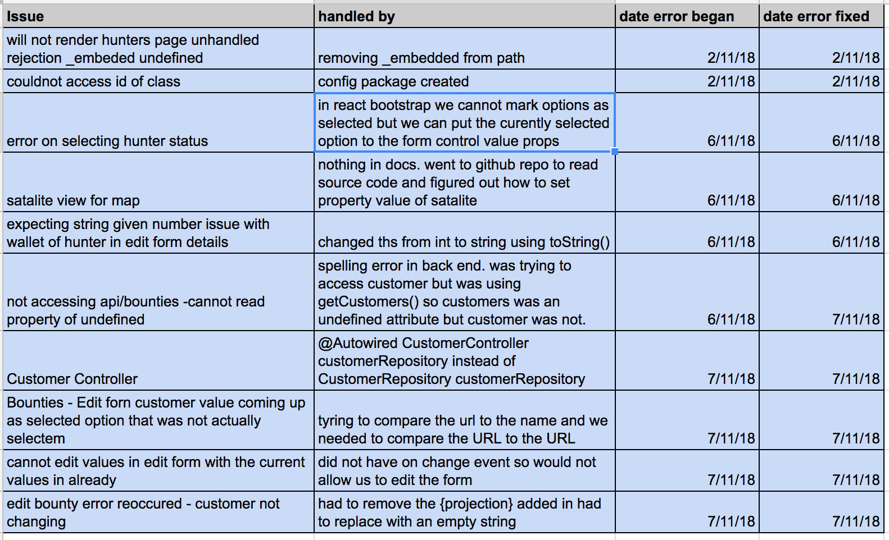

**Description here**

The above bug report was for a bounty assignment application.

**Week 12**

| Unit | Ref | Evidence |  |
| --- | --- | --- | --- |
| I&T | I.T.7 | The use of Polymorphism in a program and what it is doing. | |
|  |  | **Description**: | |

**Paste Screenshot here**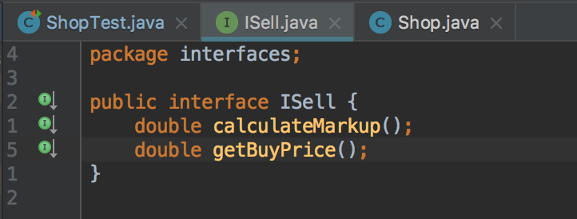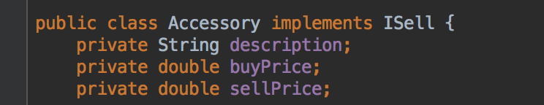

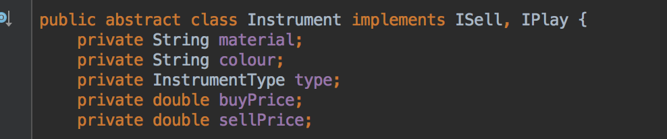

**Description here**

The stock attribute on the Shop class is an Arraylist containing objects of type ISell (Instrument and accessory). However, the array list needs to contain many objects of different classes. The ISell interface is implemented by both classes, an example of polymorphism, so they can both be stored in the stock array list.

| Unit | Ref | Evidence |  |
| --- | --- | --- | --- |
| A&D | A.D.5 | An Inheritance Diagram | |
|  |  | **Description:** | |

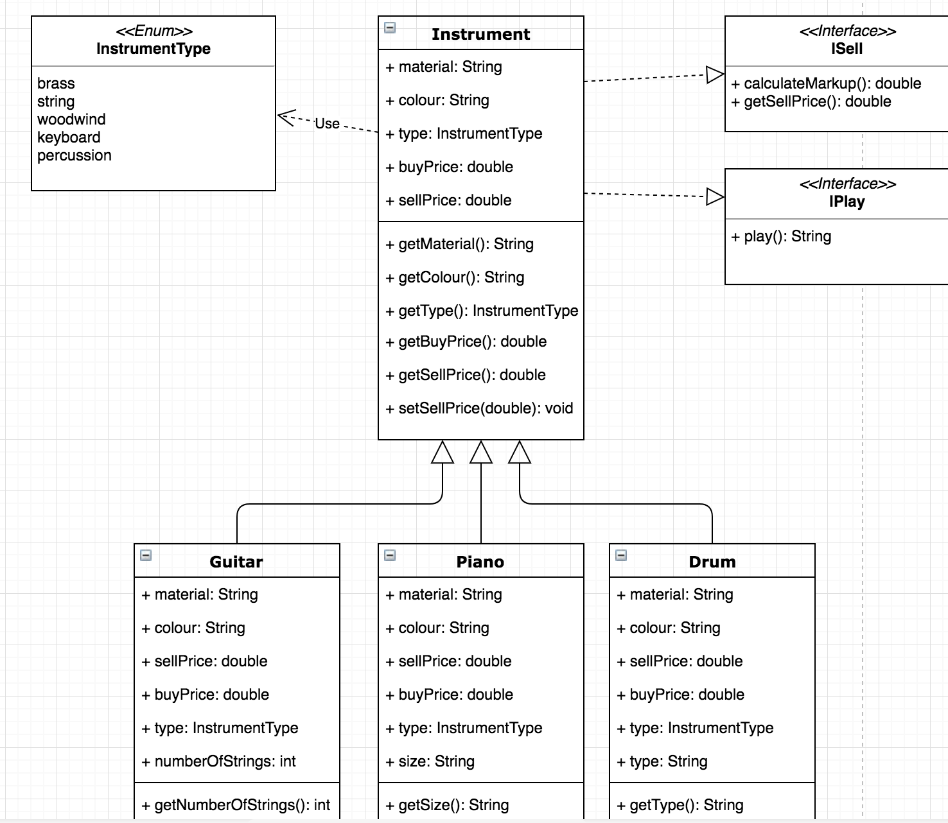

**Paste Screenshot here**

**Description here**

The above diagram shows the Guitar, Piano and Drum classes inheriting from the Instrument super class.

| Unit | Ref | Evidence |  |
| --- | --- | --- | --- |
| I&T | I.T.1 | The use of Encapsulation in a program and what it is doing. | |
|  |  | **Description:** | |

**Paste Screenshot here**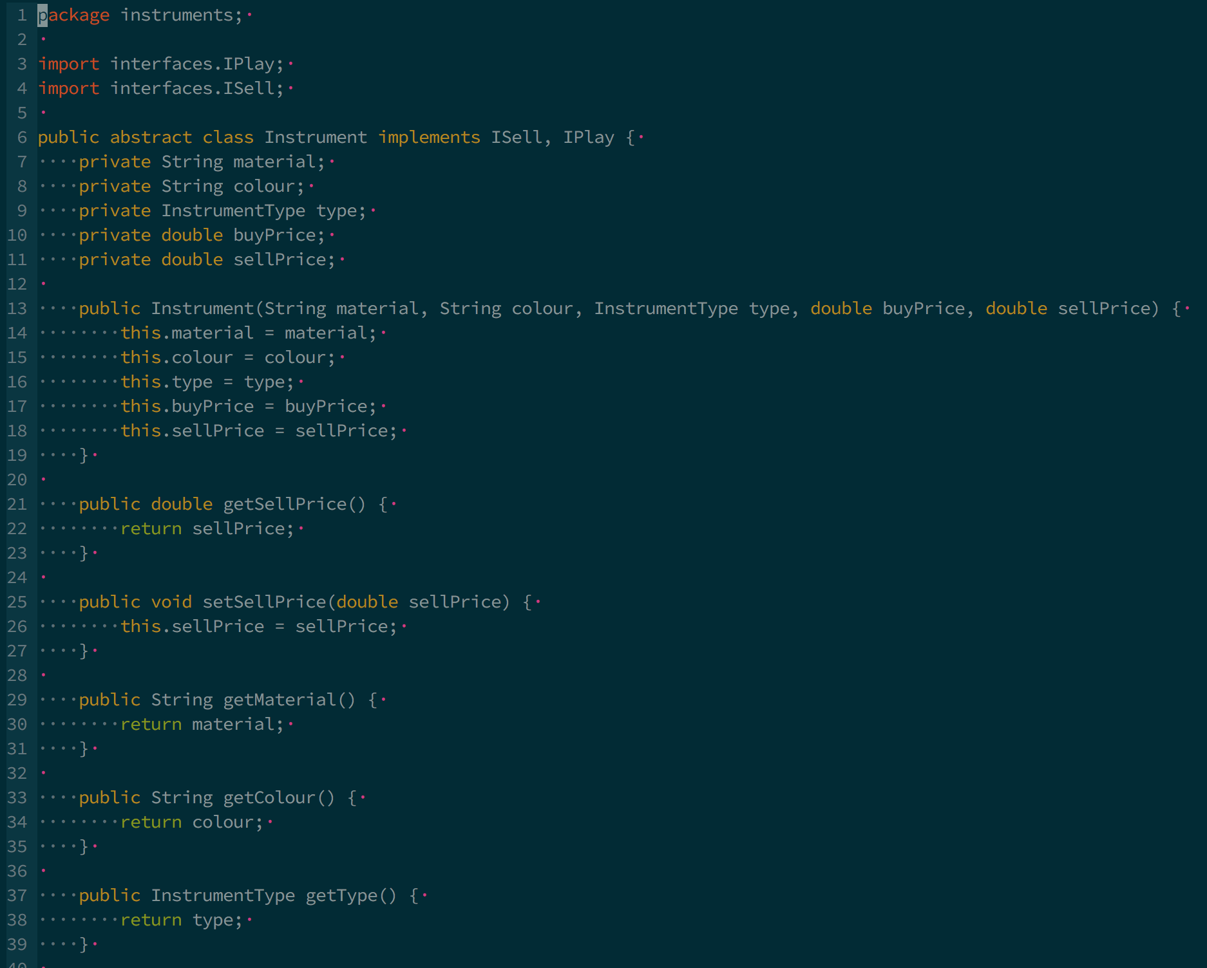

**Description here**

The screenshot above shows the use of encapsulation in a music shop program. Encapsulation is implemented here by setting the classes internal variables to private and exposing public getters and setter. Encapsulation is used here to set which properties are readable and/or writeable. For example sellPrice can be read and updated using the methods setSellPrice and getSellPrice but the property itself cannot be directly accessed. The class is responsible for managing and storing the data and the user does not need to know how, only that they can interact with the class using its public methods.

| Unit | Ref | Evidence |  |
| --- | --- | --- | --- |
| I&T | I.T.2 | Take a screenshot of the use of Inheritance in a program. Take screenshots of:  *A Class  *A Class that inherits from the previous class  *An Object in the inherited class  *A Method that uses the information inherited from another class. | |
|  |  | **Description:** | |

**Paste Screenshot here**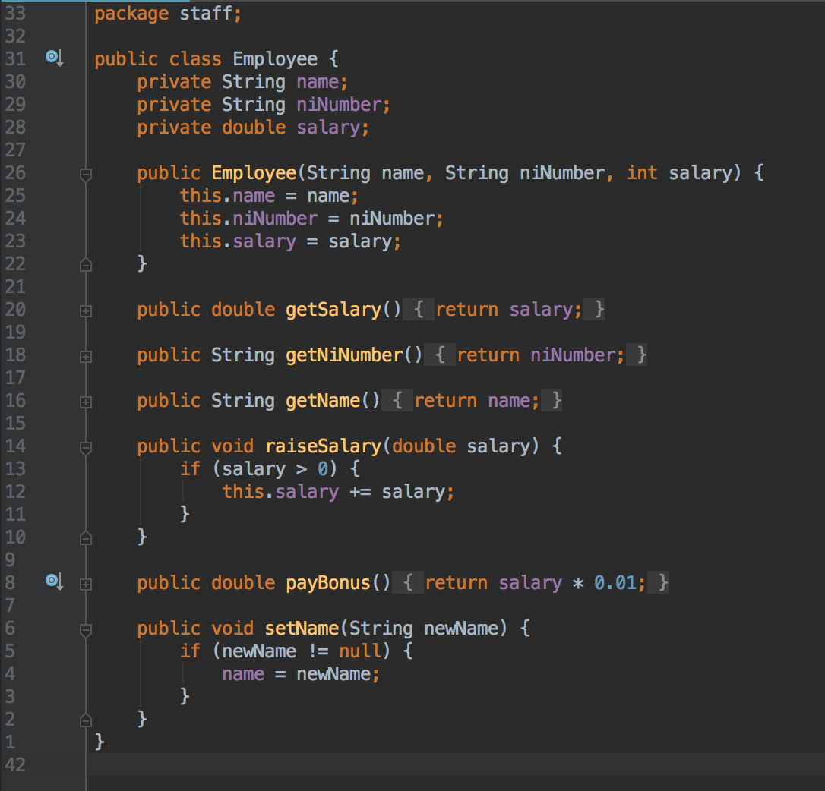

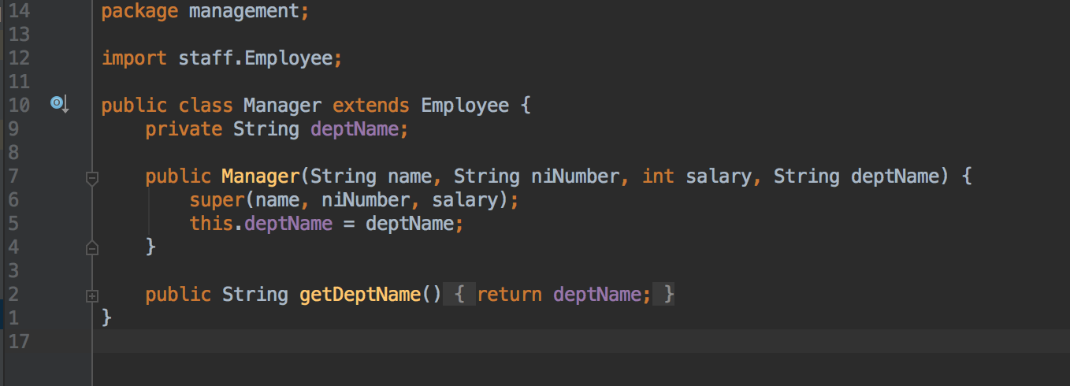

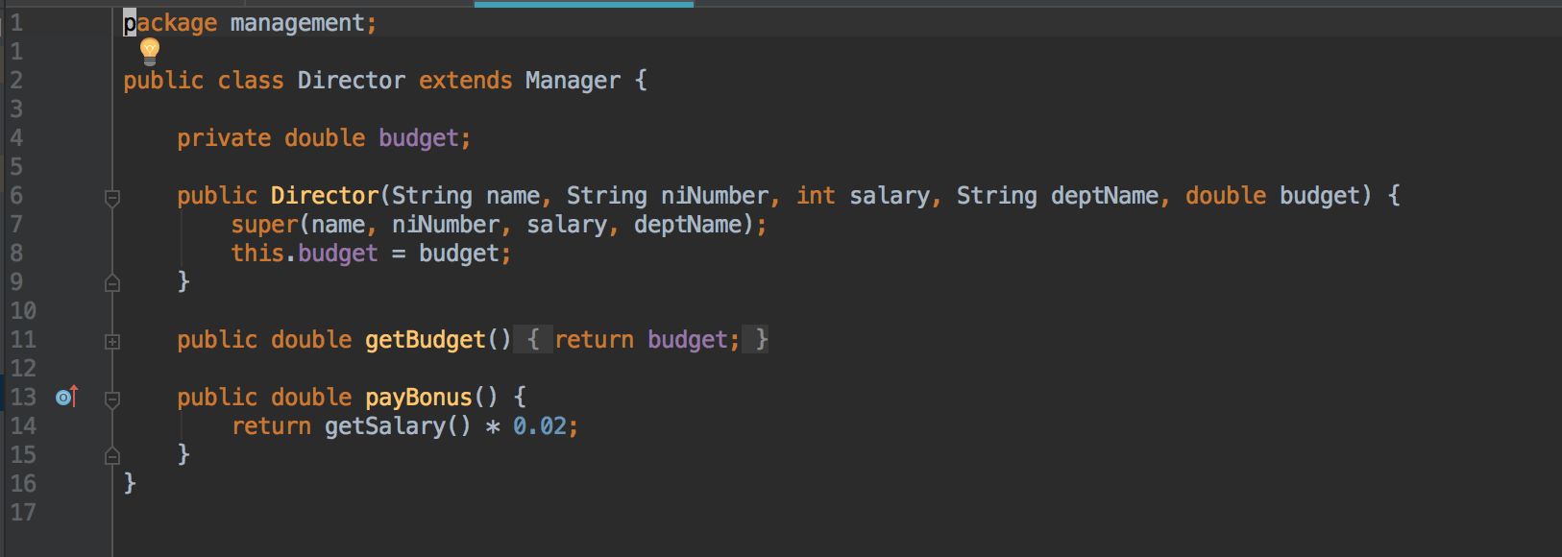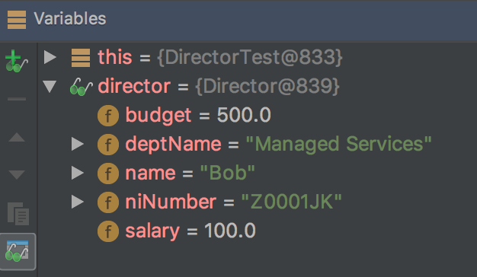

**Description here**

The 4 above screenshots show the Employee parent class, the Manager class that extends the Employee class and the Directory class that inherits from the Manager class. The payBouns method on the Director class uses information inherited from the Employee class (salary via getSalary) to calculate the directors bonus. The last screenshot shows an object instance of the Director class.

| Unit | Ref | Evidence |  |
| --- | --- | --- | --- |
| P | P.9 | Select two algorithms you have written (NOT the group project). Take a screenshot of each and write a short statement on why you have chosen to use those algorithms. | |
|  |  | **Description:** | |

**Paste Screenshot here**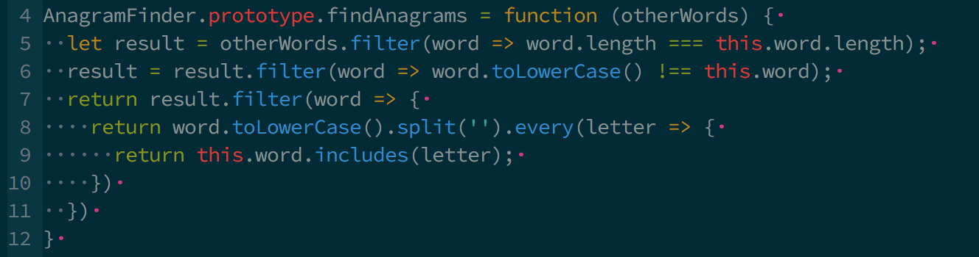

The above algorithm is used to determine if a string is an anagram. I chose to use this algorithm as it handles most, if not all, edge cases and it is efficient as the string only goes onto the next test if it passes the first.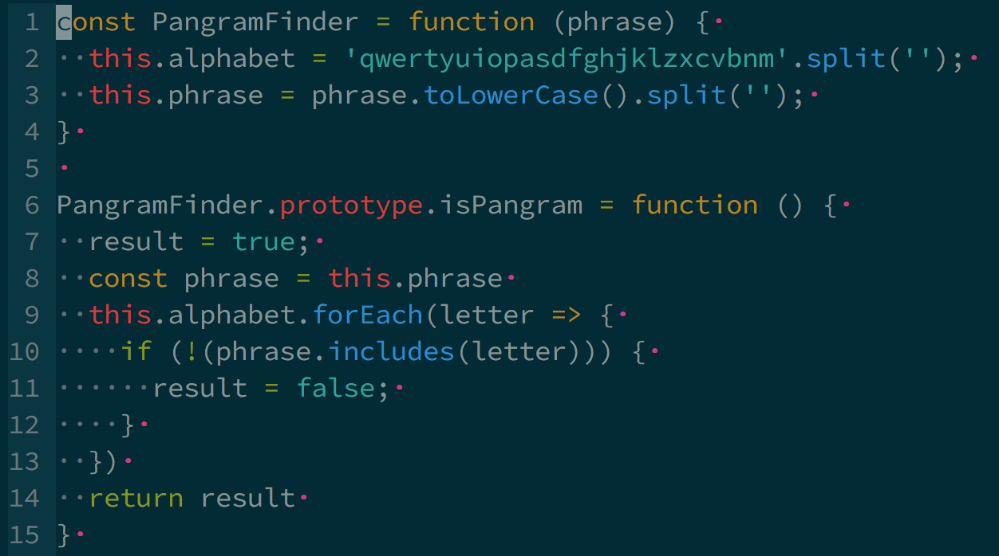

The 2nd algorithm is used to determine if a string is a pangram. I used this algorithm as it checks every letter and guarantees a valid result. Because of this it is not the most efficient approach as all letters are checked even if one has already been found to be missing.